1. **Introduction of System**

* The project titled “Banking Management System” is designed using Active Server Pages .NET with Microsoft Visual Studio.Net 2003 as front end and Microsoft SQL Server 2000 as back end which works in .Net framework version 1.1. The coding language used is C# .Net
* The project titled “Banking Management System ” is designed using Active Server Pages .NET and SQL Server 2000 which runs under .Net Frame Work 2003 in Microsoft Windows Operating System family.
* This system is used to manage the bank system which is used by bank. As we know that India has the largest number of customer in a banking sector.
* In this banking system there are 3 login places such as administration, customer and employee.

1. **Existing system**

* Our banking management system is work inside the computer system of bank.
* Our systems have three type of user.
* 1) Admin 2) Customer 3) Employee.
* With the admin control admin can create id and password for customer control and employee control and also view information about customer a/c and transaction.
* With the customer control they can
* 1) Create Account 2) Update Account 3) view reports etc…
* With the employee control employee can perform transaction, view reports, generate OTP and View transaction.

1. **Drawbacks of Existing System**

* Lack of security of data.
* Time consuming.
* Consumes large volume of paper work.
* Needs manual calculations.
* No direct role for the higher officials.
* Damage of machines due to lack of attention.

1. **Functionality of new system**

* Banking calculator.
* Online information about auction of properties.
* Loan Facility is available soon.
* Security Get improved as per new updates come.
* Blockchain technology in this data is encrypted in 128 bits and then decrypted for generating the data.

1. **Modules Description**

The Modules description of Bank Account Management System project. These modules will be developed in ASP.NET source code and MYSQL database.

1. Create New Account: A customer who having the account in the world can create an account through this module. This module receives the customer profile details

and the bank account details with the proof of the ownership of the bank account.

2. Login: Virtual account holders can login in to the system using this module. Thus this is the secured login page for the customers in the website.

3. Bank Accounts: A customer may have more than one bank account in various banks, In this case, the customer prompted to decide which bank account should reflect in the Account debit or amount credit. For these operations customers can add their owned Bank accounts here and it will be approved by the administrations of the system.

4. Fund Transfer: This is the module to make fund transfer to the virtual bank account

Holders or the usual bank account holders from the customer's specified bank

Account.

5. Beneficiary: Beneficiary is a person who receives money. Here the customer can add

The beneficiaries to make fund transfer in the future.

6. Transactions: This module displays the transactions made by the customer in the

Particular date with the transaction details.

7. Administrative Control: This module contains the administrative functions such as view all virtual account, transactions, approve bank accounts, approve virtual

accounts etc.

* 1. **SOFTWARE REQIUREMENTS**

The software used for the development of the project is:

OPERATING SYSTEM : Windows XP Professional

ENVIRONMENT : Visual Studio .NET 2003

.NET FRAMEWORK : Version 1.1

LANGUAGE : C#.NET, ASP.NET

BACKEND : SQL SERVER 2000

* + 1. **HARDWARE REQIUREMNTS**

The hardware used for the development of the project is:

PROCESSOR : PENTIUM III 866 MHz

RAM : 1 GB or More

MONITOR : 15” COLOR

HARD DISK : 20 GB

CD DRIVE : LG 52X

KEYBOARD : STANDARD 102 KEYS

MOUSE : 3 BUTTONS

**5.2 Tools and Technologies used**

**Integrated Development Environments**

* Ms Visual Studio

**Programming language**

* C# language is used applying condition and editing in our program.
* Front End HTML and CSS is used for designing purpose.

**Server**

* SQL Server/ Management Server

**UML Tools and Technologies**

* MS Visio

**Framework**

* Ms visual studio 3.5 framework

1. **System Users**

1. Administrator

2. Employee

3. Customer

1. Administrator: - The role of bank admin is to create id and password for customer control and employee control for website. Admin can also view all transaction and all information of customer.

2. Employee: - The role of Employee control is to view reports of customer account and also done transaction according to need of customer and also generate OTP (one time password) for transaction.

3. Customer: - The role of Customer control is to create new customer account according to application form and also update account if needed and view reports of customer account and also can change password, view transaction report.

7.**DFD**

**7.1 Context Level DFD Banking Management Systems**

Login and Manage A/c Account summary/Report

Banking Management System

Admin

Customer

Employee

Edit and Takes Reports Login & Account Details

Transaction Reports Login and Create Transaction

7.2 1st Level DFD Banking Management System

Banking Management System

**Customer**

**Management**

**Employees**

**Management**

**Generate Fixed**

**Deposit Reports**

Report

**Generate**

**Accounts Report**

**Generate**

**Employee Report**

**Fixed Deposit**

**Management**

**Accounts**

**Management**

**Generate**

**Customer Report**

**Saving Account**

**Management**

**Current**

**Management**

**Generate**

**Current Account Report**

**Check**

**Saving Account Details**

**7.3 2nd Level DFD Admin Banking Management System**

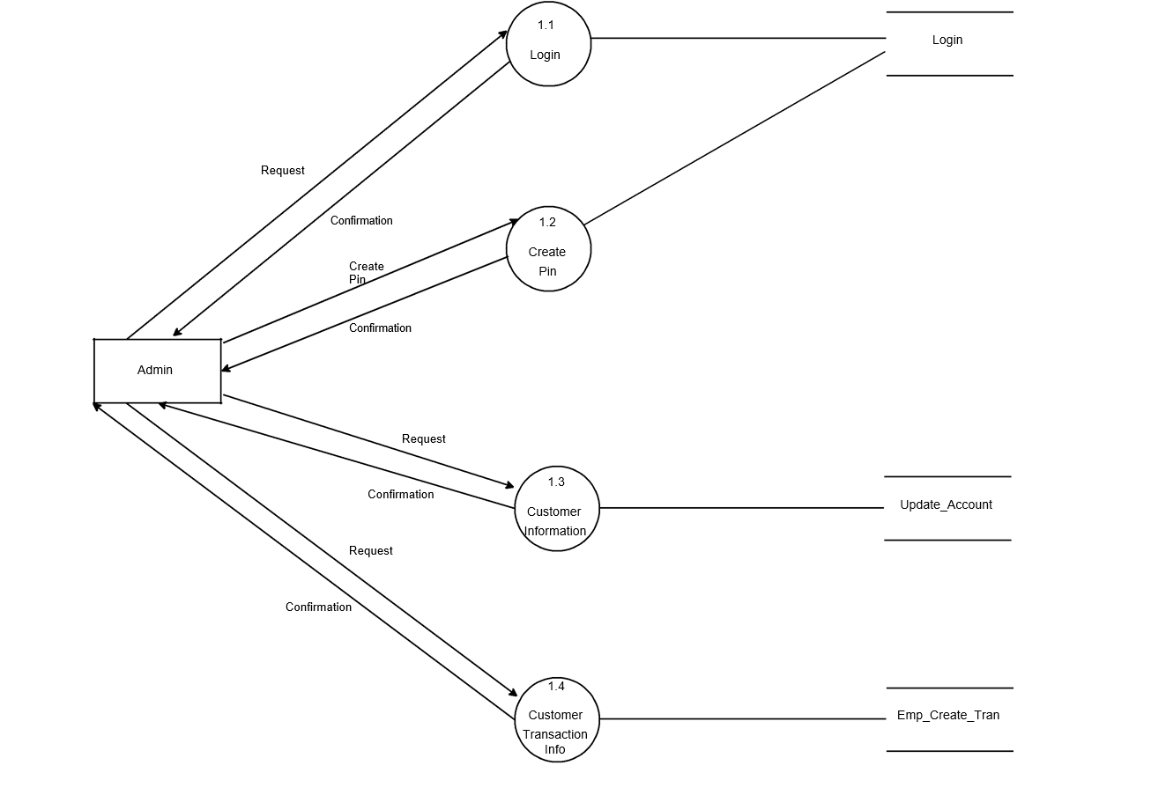

**7.3(1) 2nd Level DFD Customer Banking Management System**

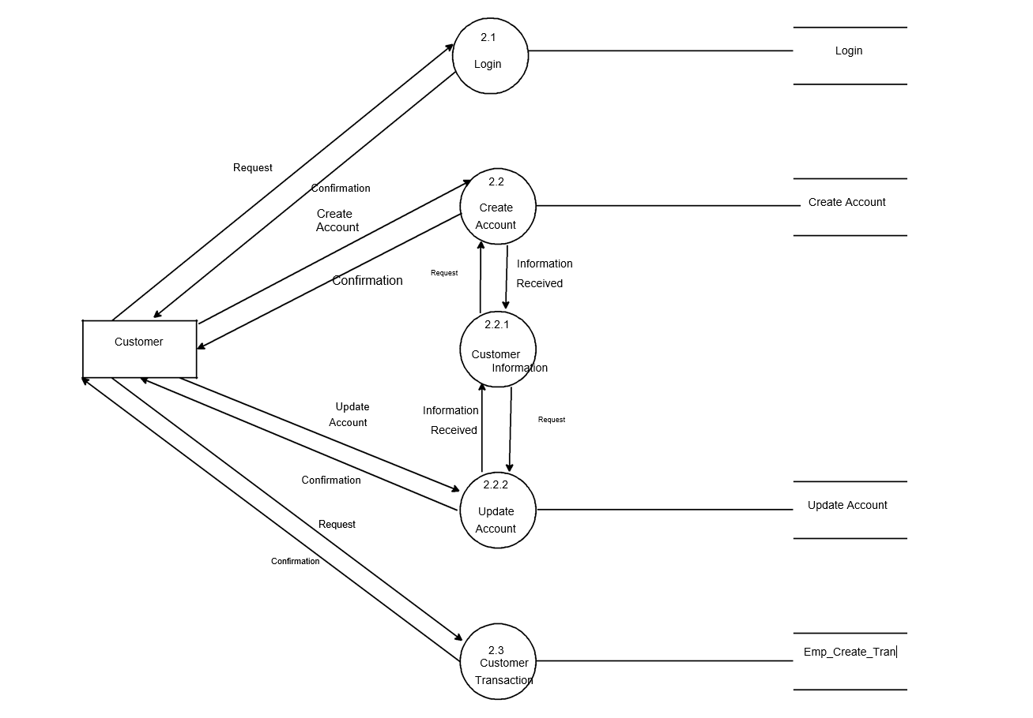

**7.3(2) 2nd Level DFD Admin Banking Management System**

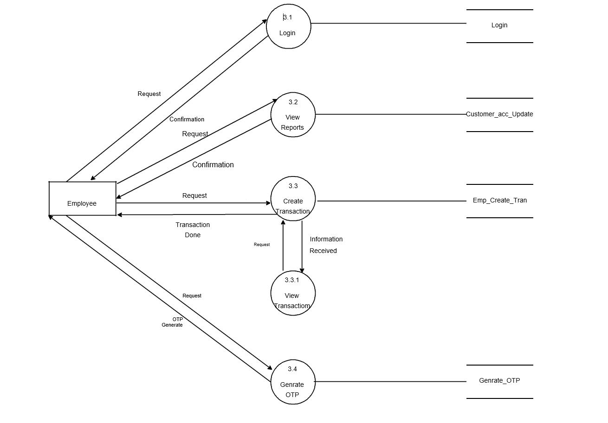

1. **E-R Diagram for Banking Management System**

**Admin Info**

Admin

**Branch**

Contact No.

Branch Name

Branch

City

Loan

Branch

**Loan**

**Customer**

Borrow

Loan-No.

Amount

Customer

Customer-ID

Customer-Street

Customer-City

Customer A/c Info

**Account**

Category

Balance

A/c Number

**Transaction**

Deposit

Withdrawall

A/c Transfer

1 M 1 1

1 M

1

1

M M M M

**9. Activity Diagram**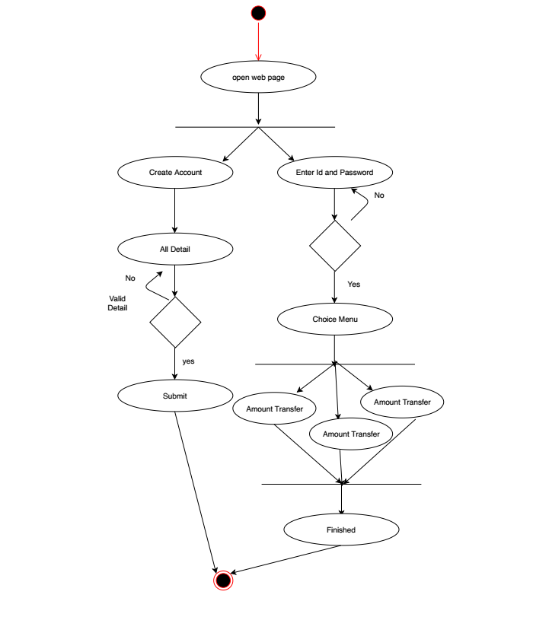

1. **USE CASE Diagram**

Login

Create A/c

Update A/c

Delete A/c

Transfer

Withdrawal

Deposit

A/c Info

Tran. Report

Year Report

Log out

Customer

Employee

Admin

1. **Data Dictionary**

|  |  |  |
| --- | --- | --- |
| Sr No. | Table Name | Description |
| 11.1 | Branch Info | This table contains information about bank branch such as branch no. And branch name. |
| 11.2 | Deposit Info | In this table it contains the information about amount and depositor who has deposited amount in account. |
| 11.3 | Login table | It is the very first step to access the bank account.it contains username and password. |
| 11.4 | Withdrawal Info | In this table it contains the information about amount and withdrawer who has deposited amount in account. |

11.1 Branch Info

|  |  |  |
| --- | --- | --- |
| Fieldname | Type | Constraints |
| Branch no | Varchar(7) | Primary key |
| Branch name | Varchar(20) | Not Null |

11.2 Deposit info

|  |  |  |
| --- | --- | --- |
| Fieldname | Type | Constraints |
| Account no | Int | References Account info(Account no) |
| Branch no | Varchar(20) | Null |
| Depositor name | Varchar(20) | Not Null |
| Account type | Varchar(20) | Not Null |
| Deposit amount | Varchar(20) | Not Null |
| Deposit Date | Date Time | Not Null |

11.3 Login table

|  |  |  |
| --- | --- | --- |
| Fieldname | Data type | Description |
| Username | Varchar(20) | Primary Key |
| User Password | Varchar(15) | Not Null |

11.4 Withdrawal Table

|  |  |  |
| --- | --- | --- |
| Fieldname | Type | Constraints |
| Account number | Int | References A/c info(Account number) |
| Branch no | Varchar(7) | Null |
| Withdrawal name | Varchar(15) | Not Null |
| Account type | Varchar(15) | Not Null |
| Withdrawal | Varchar(15) | Not Null |

=

**12.Form Design (Screenshots)**

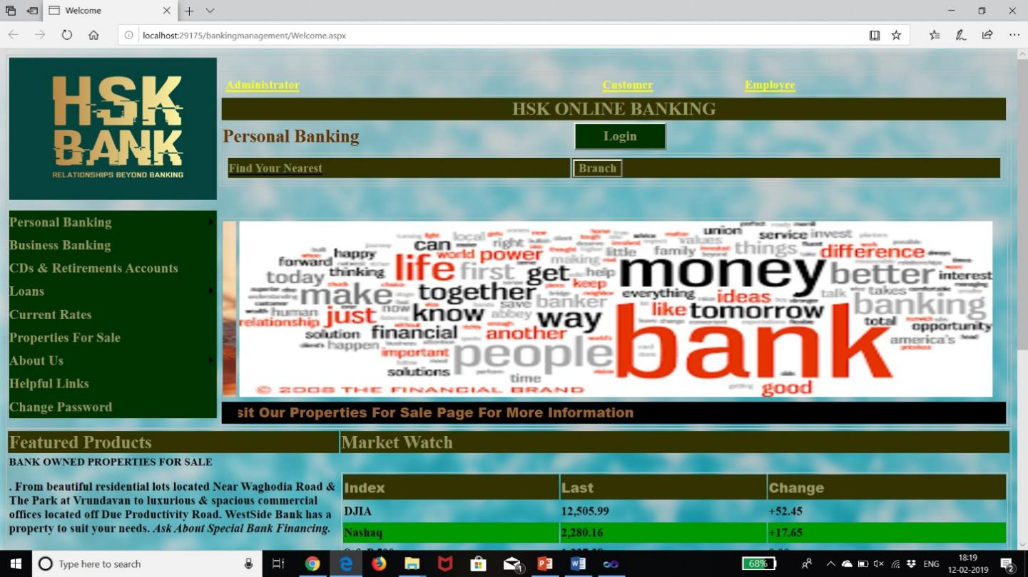

Fig 12.1 Main Page

This is the main page which is shown on when we open the web page and it is also known as homepage or Master page.

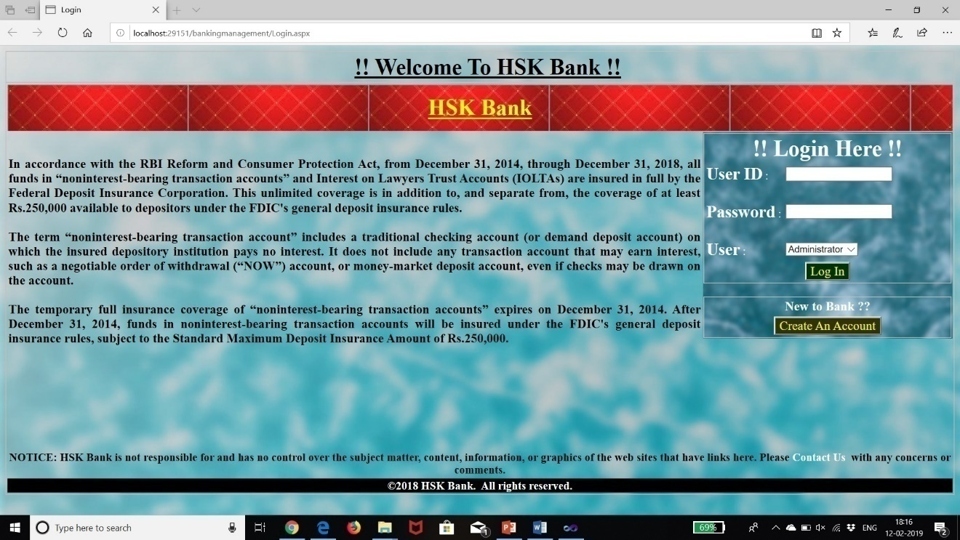

Fig 12.2 Login Page

After the homepage this page comes which is the login page which allows the user to access into the server.

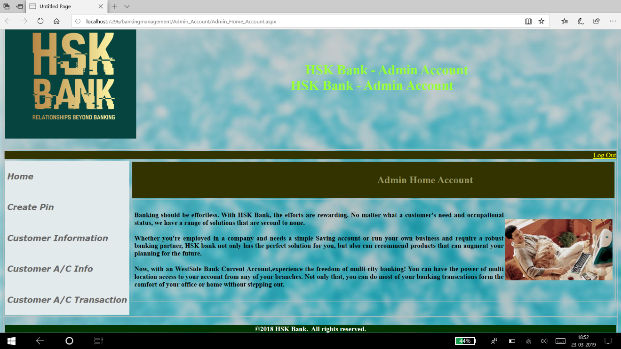

Fig 12.3 Admin Home Account

After login into the admin page we see the above page which we used to check the reports of all the things

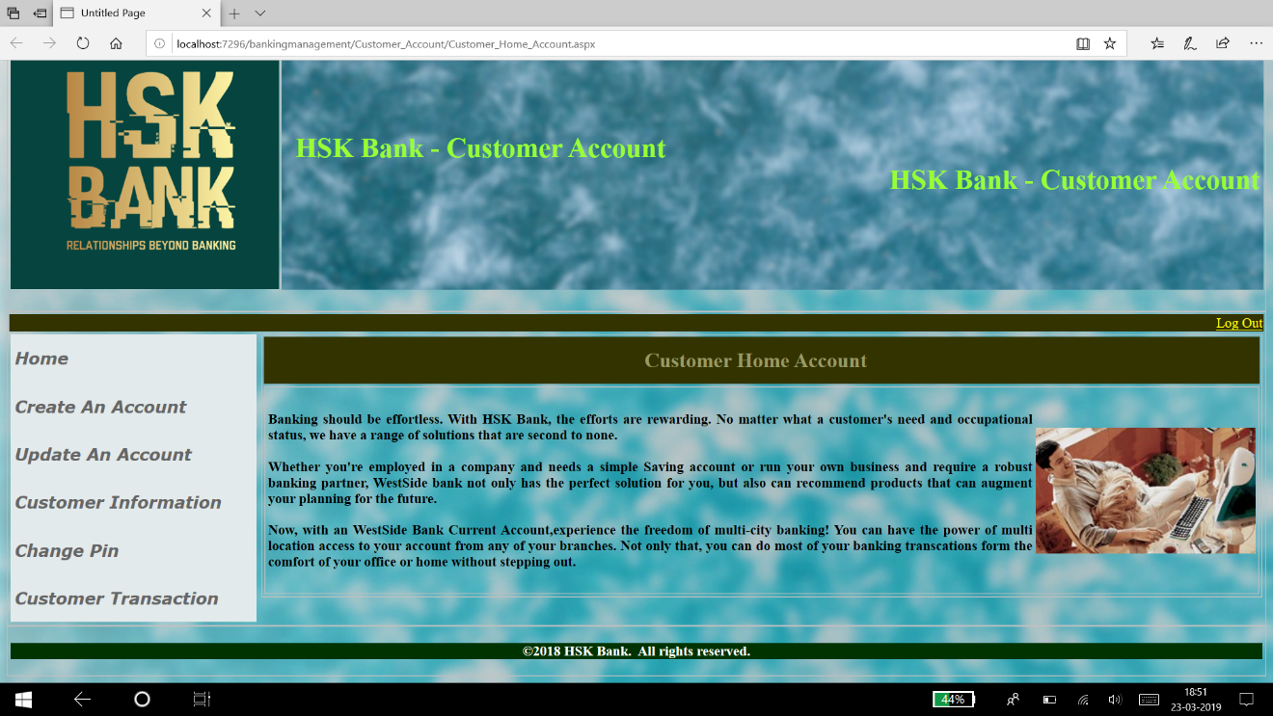

Fig 12.4 Customer Home Account

This page occurs when we login with customer account and it is the path which is used for taking the reports of the particular customer.

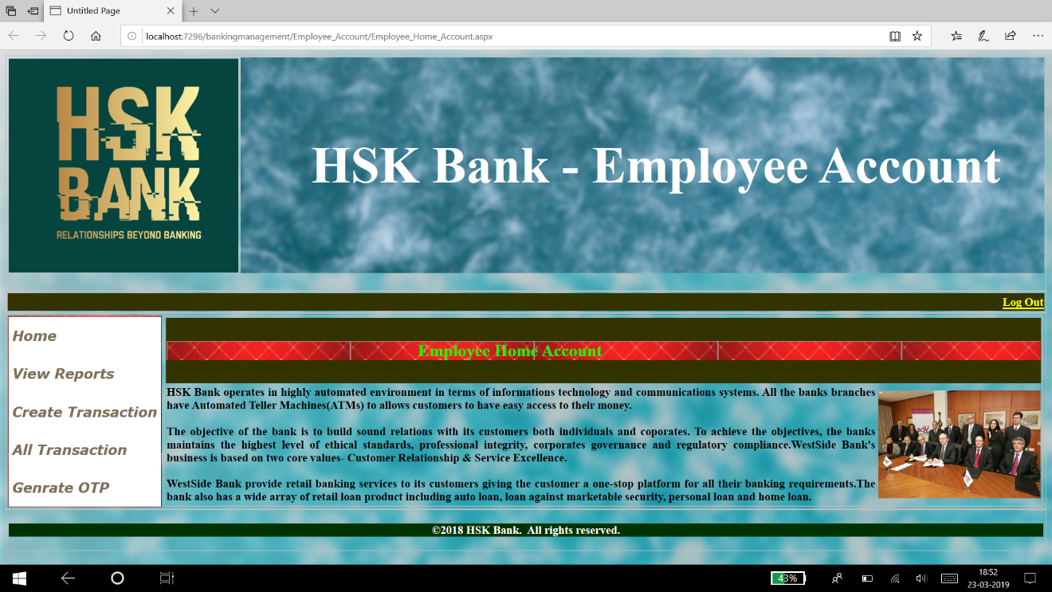

Fig 12.5 Employee Home Account

This is the actual page is view when we make want to transfer money from the bank person such as when we visit the bank the employee work is actual done in this phase.

**13.Future Enhancement**

Current status of project: -This project is now wards complete but we can add more things like ATM, Online Transactions through Online Banking.

Remaining areas of concern: - This software project is complete and can be used to access records, can generate reports whenever necessary or needed.

Technical and managerial lessons learnt : - During the development of project we have learnt many lessons like the rules prevailing within an organization like: -

Proper defined structure.

Good chain of commands.

Work should be divided among each other.

Effective and efficient environment for working and development.

Future recommendations: -As we all know that the change is permanent, so according to change this project can be modified or manipulated according to needs.

Joint Account facility will be added in our services.

**14.BIBLIOGRAPHY**

**W3School-** we have learn several command using this website which make us to execute our program as we know that without studying from latest technology we cannot make our project.

**YouTube-** The second most useful for developing our project is YouTube in which we watch video for implementing our program such as connecting database, firing query and many more.

**Books**

1. Learning ASP.Net and C# .Net. **-**Ramesh Baangia.
2. ASP.Net 4 - Stephan Walther.

**Web References**

**<https://www.w3schools.com/asp/webpages_intro.asp>**

**<https://www.tutorialspoint.com/asp.net/>**

**<http://www.pragimtech.com/free-aspnet-video-tutorial.aspx>**